SUSPENSION TRAINING
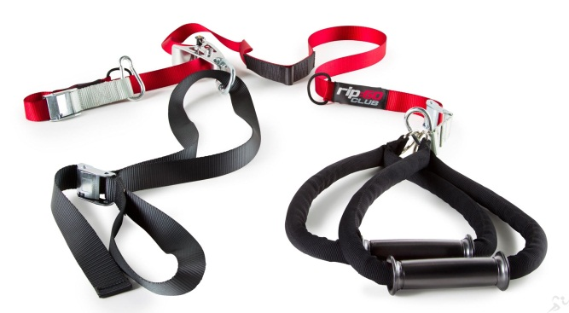
Optimise Your Workout…Not compromise it!
Innovative Education
Integrating both on and off strap movements, the Rip:60™ Education delivers a unique, high calorie-burn workout. The sequencing also utilizes functional training with push, pull, trunk and lower body methodology, working each side equally. This also allows for ample recovery time and faster results.
Simple Design
The unique design of the Rip:60™ Trainer is perfect for anyone of all levels. It adjusts with every movement so you get the workout you want. It’s made of aircraft-quality aluminum and heavy-duty nylon with comfortable hand and ankle straps. This system holds up to 600 lbs or 270kg of weight.
Optimization Zone
Every workout offers a beginner, intermediate and advanced position. More extreme body angles or positions create a higher intensity and challenging workout while smaller angles make the workout easier. If you feel fatigued during your last few repetitions, simply adjust your angle and keep moving!
Suspended Rotation
The secret to Rip:60™ Training is suspended rotation. Your body is being
forced to stabilise and balance throughout your entire workout so you are recruiting more muscle and constantly activating your core with every exercise movement.

Call us @66844158 or 91148165 for a Free Trial class!

For more information about Rip60 Suspension Training, please click here.


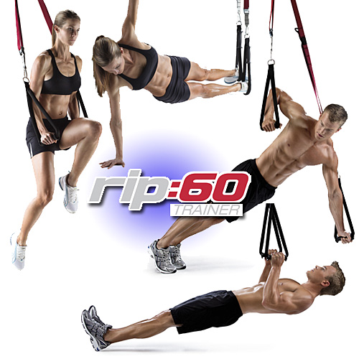

If you want to lose fat and gain muscle at the same time using just your bodyweight then you need to try suspension training. Suspension training involves using a device to literally suspend your entire, or a part of your body, off the floor. This technique will make all of your typical bodyweight movements 10 times harder
With most bodyweight training programs, you still need a pull-up bar. But you can’t take a chin-up bar with you everywhere. That is where Suspension Trainer comes in.
But first things first: you want to have a sexy body. Convenience is #1 to getting you your dream body. The second thing is to have a challenging workout. And once you incorporate suspension training into your regimes, you will be challenged beyond belief! Even a basic press-up will turn into the most challenging exercise you have ever done!

Let us go over the 5 Facts that makes Suspension Training so awesome:

Fact #1: It Does not require A lot of Equipment or Space, but…
Suspension Training is a lot more fun than going to the gym and lifting weights. It’s a lot faster too. You can have 8 to 10 exercises in a sequence for a set, you spend for 1 minute on each exercise. So that is a quick, intense, 16 to 20 minutes workout(this normally involves 2 sets) that does not require a lot of space. All you need is just the Suspension Trainer and your bodyweight!
Now, why not just stick to regular bodyweight training? Well, you can, but how would you train your back? You can’t walk around with a chin-up bar. But, you CAN actually make it happen using the Suspension Trainer. That’s really all the equipment you will need. With this simple piece of equipment, you can train your back, chest, shoulders, legs, and abs!

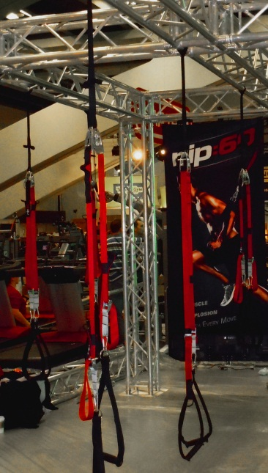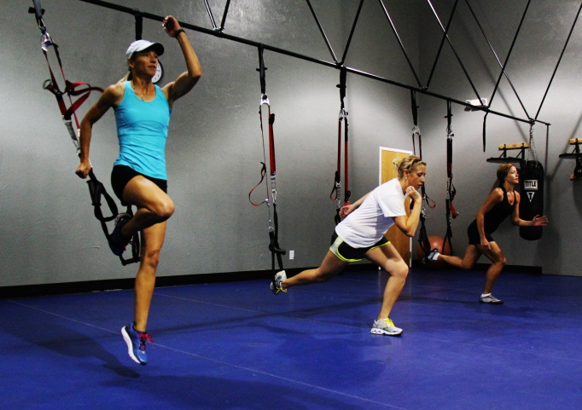

Fact #2: Gym Machines and Traditional Barbell Movements can cause Injury, but…
With a Suspension Trainer, you will hardly experience sore shoulders, aching backs, and pain in your joints that you normally experiences with gym machines and barbell movements. So ditch running on your treadmill like a hamster and going through the motions at the gym and experience something truly safe and exciting by following a set of simple rules or principles.
I have done it all – heavy weight training, gym machines, lots of running, etc. Excessive running has caused bad knees. However, once I switched over to bodyweight training, all my aches and pains went away. So, we already know that bodyweight training is the safer alternative! You just need to use suspension training to make your workouts harder.

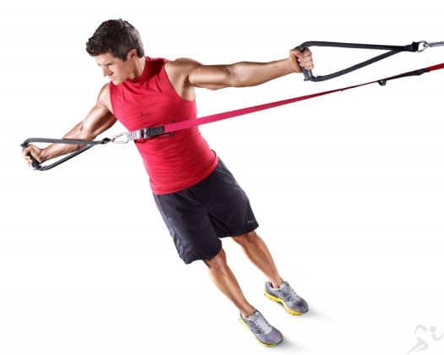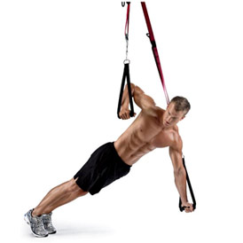

Fact #3: Cardio doesn’t work, but…
Short, burst workouts work! There was a study that proved that even if you did 1 hour of cardio every day for a year, you’d only burn 5 pounds of fat! Very bad results. In fact, fast and higher intense workouts help you burn of all your stubborn fat for you. Combine that with a solid diet, and you’ll have your dream body in no time!
What people don’t realize is that weight loss is a function of a calorie deficit. So you need to burn more calories than you consume. However, cardio is NOT the most efficient way to burn calories. The key to burning lots of calories is to boost your metabolic rate, and you can do that with short, burst workouts.
Also, cardio does not differentiate between fat and muscle. So, a great way to lose muscle is to do lots of cardio. Look at the difference between a distance runner and a sprinter. Sprinters are lean and muscular. Runners are lean, but they are not very muscular. Most distance runners look like they are anorexic.
Another problem with cardio is that people get hungry, and they eat. Now, let us say a session of cardio burns 200 calories. Now, your meal will probably need 200 calories. Now you have just gotten rid of any benefit of the cardio you performed. A better option is to increase your metabolic rate, so that the calories you eat are used right away and burnt off.

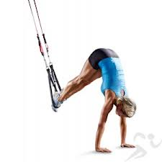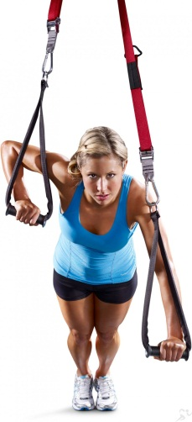

Fact #4: You Can’t Turn Fat into Muscle, but…
You can build muscle to burn fat. The way it works is like this: you do challenging movements that stress your body and build down muscle mass. Eat right. Eat a lot. Eat protein. And you re-build that muscle bigger and stronger. With big muscles comes a faster metabolic rate, because now your body needs more calories to maintain that muscle. Keep your caloric intake the same, and your body uses the fat calories to support new muscle growth!
How is Suspension Training challenging? Well, bodyweight training in itself is pretty tough. But when you add in suspension training, each and every exercise you do, you gets tougher. For example, I can do 30-40 pushups easily. But when I did pushups using the Suspension Training system, I could barely pump out 5 repetitions on my very first attempt!

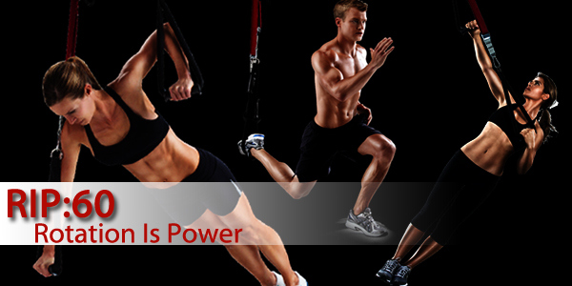

Fact #5: Crunches won’t help you Lose Fat, but…
According to Men’s Health magazine, you need to do 22,000 crunches to burn off 1 pound of fat. Do you have time to do that many crunches? Besides, crunches cause you to have a bad back. I will not get into it, but if you want a solid midsection, then you need to do movements that stabilize your core. And Suspension Training has the movements that you are looking for!

Let’s go into what a stabilization exercise is all about. Do this: get down into a press-up position. Notice how your abs get tightened up. Do a few push-ups, and you will see just how much your abdominals are working. Press-ups train your abdominals more effectively then sit-ups and crunches!
Suspension Training has a lot of great abs-specific(core & stability) movements. However, as a mentioned before, even doing pushups on the suspension training system is going to be tough. So, you will actually get an abdominal workout with EVERY single movement you perform! All you have to do is take care of your diet, and you will see your abs!
What we’re talking about here is a mind-set change. You’re used to going into the gym and training each body part at a time. Now, get used to training your ENTIRE body in one session. 20 minutes, 10 exercises of 2 sets, and your abs are going to be SCREAMING in pain. Suspension Training is the only workout you need for your abs.

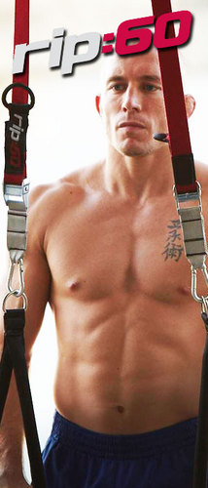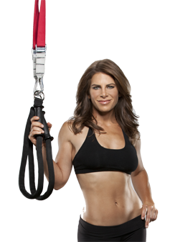
Train Like The Pros
Leaders in fitness like Jillian Michaels and Georges St. Pierre not only endorse this wonderful system but also rock the Rip:60™ Trainer.


